Finance Chapter Project – “Buying A House”
MATH 1332 College Mathematics
April 5 2019

Property Details
Address: 10110 Fallmont Ct, Houston, TX 77086
- Single Family, One Story, Ranch Style
- 5 bedroom 3 full baths, Rustic barn doors, Spacious closets.
- Main living area has a wide-open floor plan with beautiful light fixtures
- Sq. Ft. (Main) 2,654
- Equipment: Carbon Monoxide Detector, Cooktop (Electric), Dishwasher, Range/Hood, Refrigerator, Security System
- Deck, Porch – Covered
- 2 Parking Spaces
- Spacious back yard with wooden deck perfect for cookouts.
- Master bedroom is located upstairs along with 3 bedrooms and a game area.
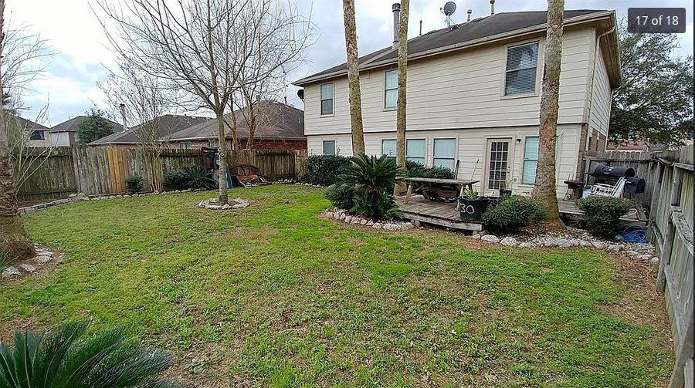
Listing Price:
$170,000
The Purchase Price: $170,000
Current Real Estate Tax Rate in Houston, TX: $0.588310 per $100
Current Market Interest Rate for a conforming 30-year fixed-rate mortgage with a 20% down payment: 3.625%
References: https://smartasset.com/taxes/texas-property-tax-calculator#kUfyqGxnt3

%20Rates.pdf https://www.usbank.com/home-loans/mortgage/conventional-fixed-rate-mortgages.aspx

https://www.zillow.com/homedetails/10110-Fallmont-Ct-Houston-TX-77086/62590287_zpid/?utm_source=Trovit&utm_medium=CPC&utm_campaign=campaign1

Down Payment = purchase price (10% of down payment in decimal form) Down Payment = $170,000(0.10) The Down Payment would be $17,000.
Amount Financed = purchase price – down payment
Amount Financed = $170,000-$17,000
The amount financed would be $153,000
Monthly Mortgage Payment: 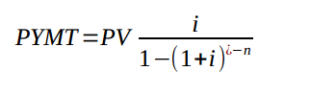
$$i=\frac{0.02259}{12}=0.00188$$
i=0.00188 n = 30 years(12months) n = 360 payments
$$PYMNT=153,000×\frac{0.00188}{1-{(1+0.00188)}^{-360}} =556.66$$
The monthly mortgage payment would be $556.66.

Yearly Real Estate Tax Amount = Tax Rate Amount (Purchase Price/$100)
Real Estate Tax Amt = $0.588310 ($170,000)/$100
Real Estate Tax Amt = 0.5883(1,700)
Yearly Real Estate Tax Amount = $1,000.11
$1,000.11/12month = $83.34
The monthly amount to real estate taxes would be $83.34
Total Monthly Payment = monthly mortgage payment + monthly real estate tax payment Total Monthly Payment = $556.66 + $83.34 The total monthly payment would be $640.00.
Minimum monthly income needed for loan (monthly payment cannot exceed 28% of person’s monthly income):
28% (monthly income) = monthly payment
0.28x = 640
0.28x/0.28 = 640/0.28
X = $2,285.71
The minimum monthly income required to qualify for the loan is $2,285.71.
Minimum annual income = minimum monthly income (12 months)
Minimum annual income = $2,285.71(12)
The minimum annual income required to qualify for the loan is $27,428.52.
Compute the monthly amount of real estate taxes and add to the monthly mortgage payment to get the total monthly amount paid.
Here is the house I chose for this project; this advert is found in, https://www.zillow.com/homedetails/10110-Fallmont-Ct-Houston-TX-77086/62590287_zpid/?utm_source=Trovit&utm_medium=CPC&utm_campaign=campaign1
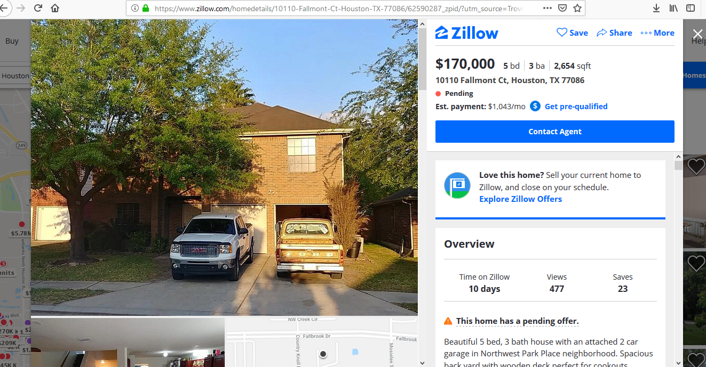
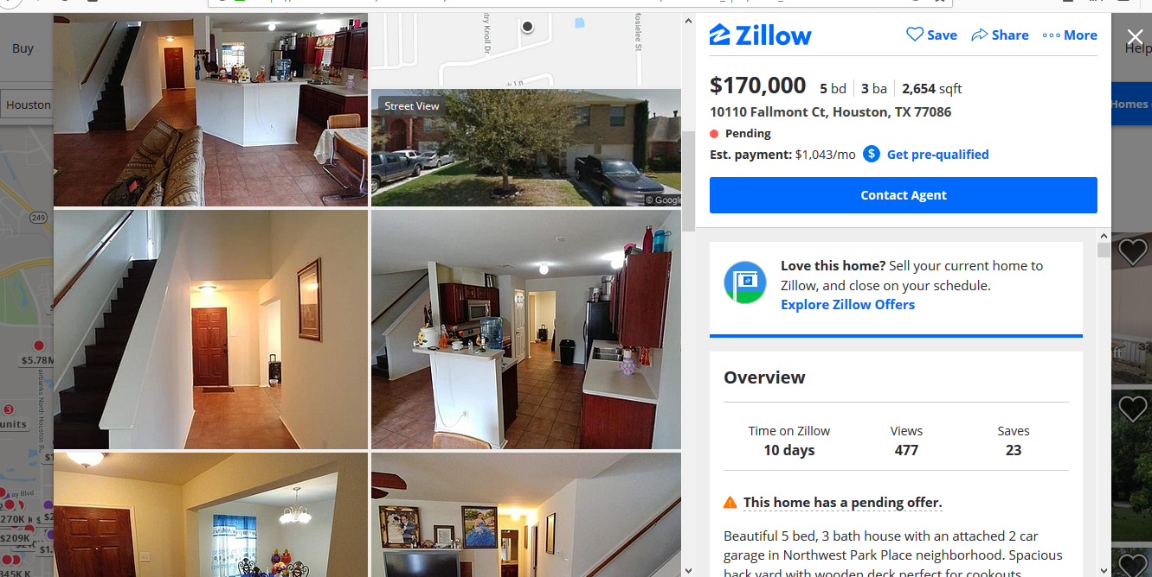
According to the requirements, it is big and spacious enough to host the kids and their grandma in case she visits and she could even live here.

References

